Edge Search algorithm

Edge 1

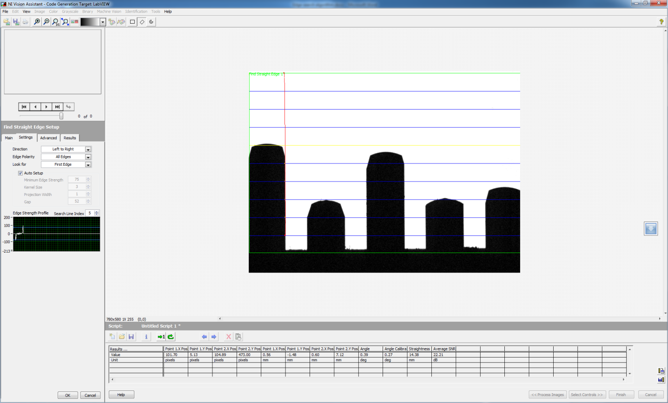

Edge 2

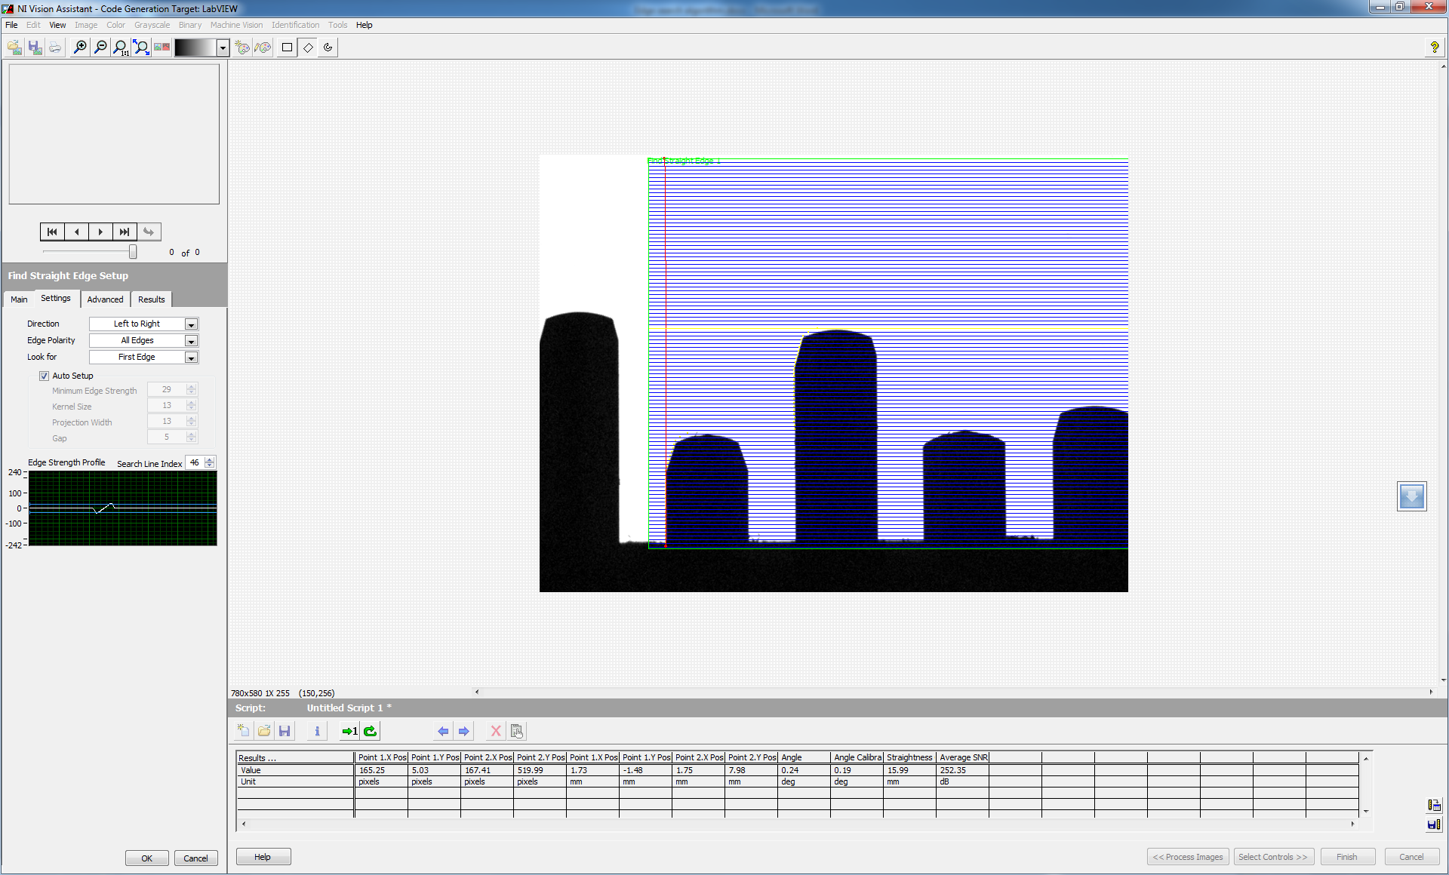

Edge 3

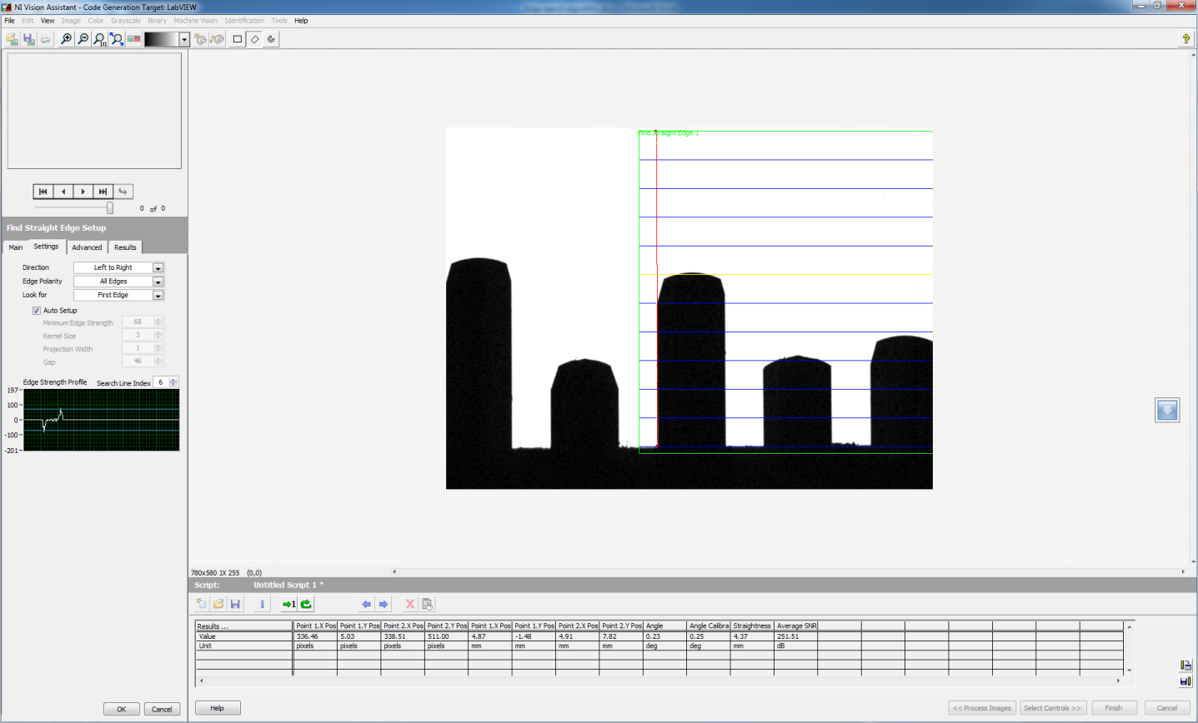

Edge 4

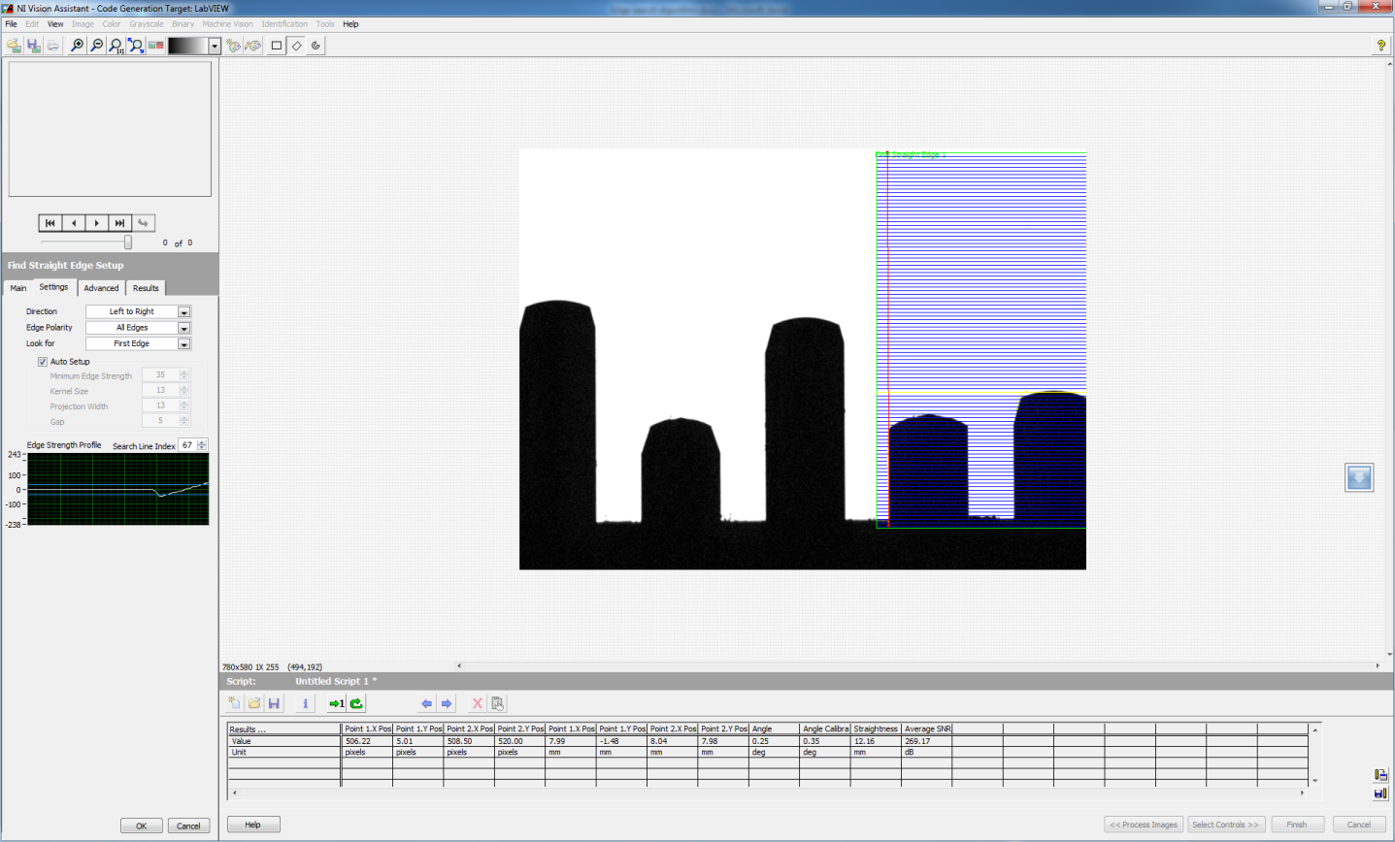

Edge 5

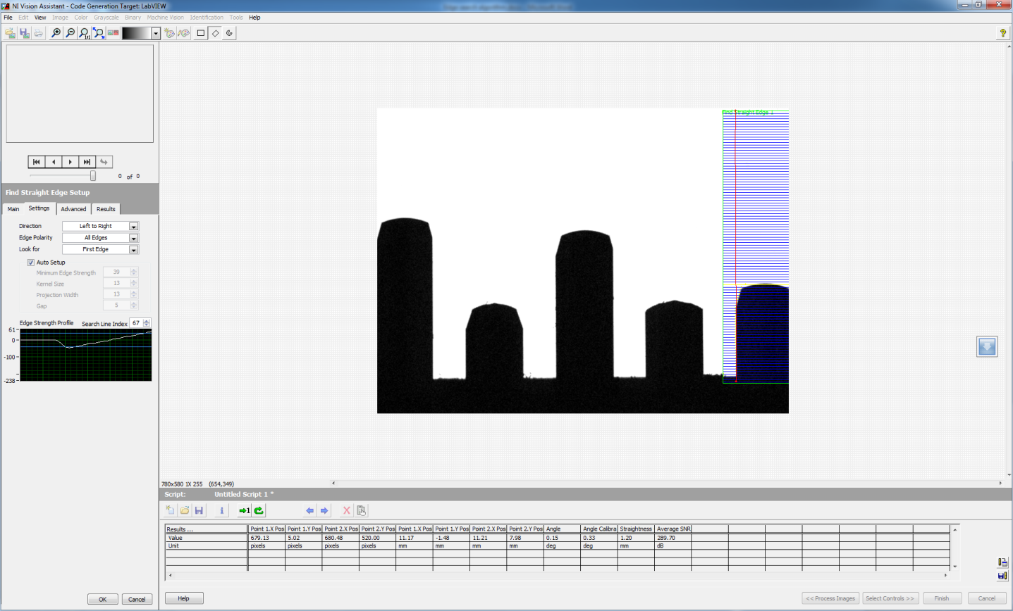

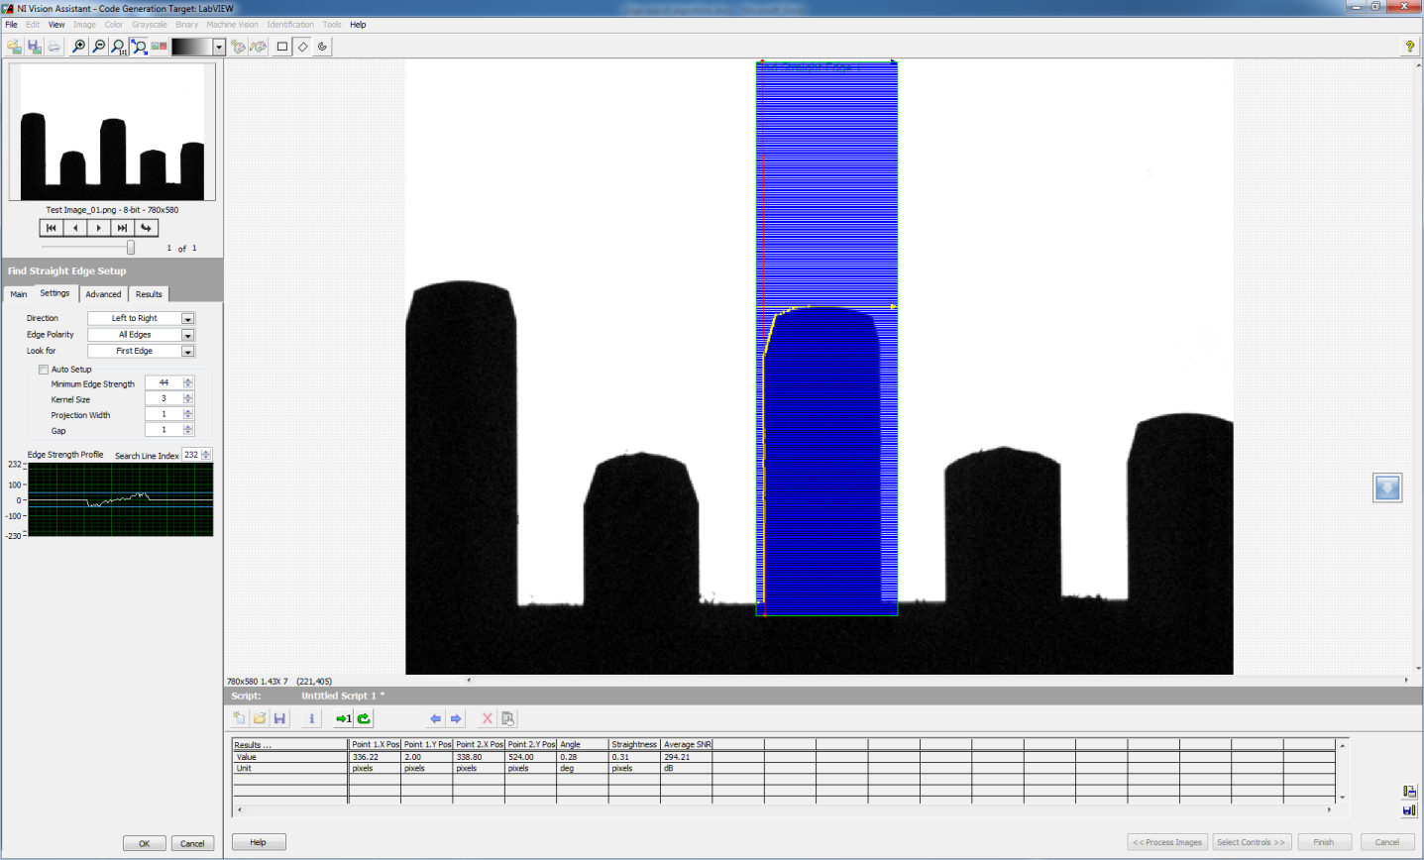

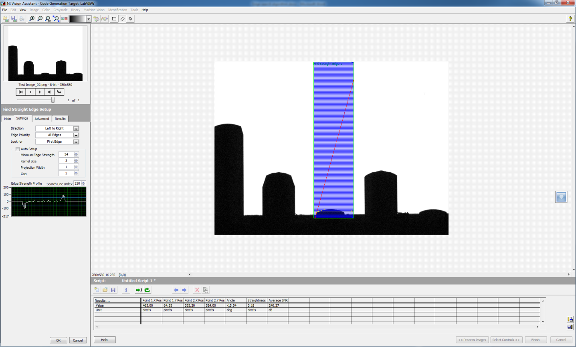

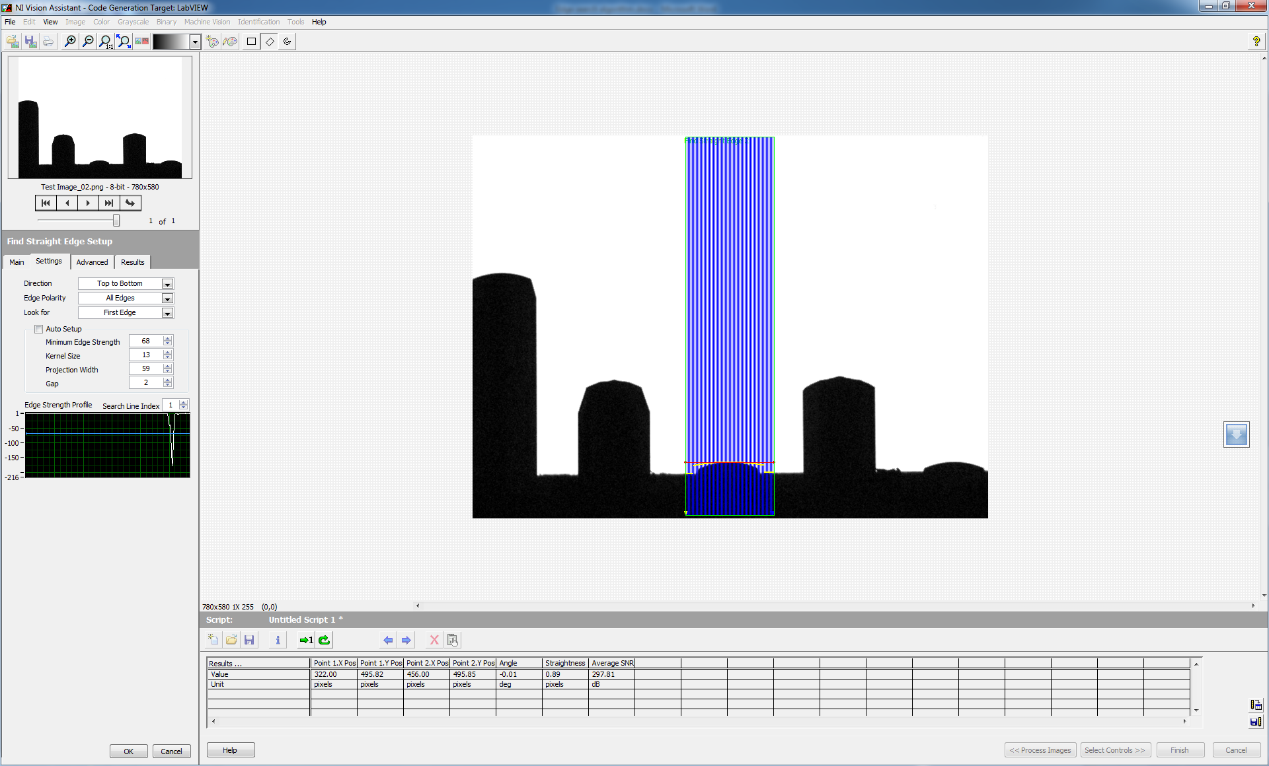

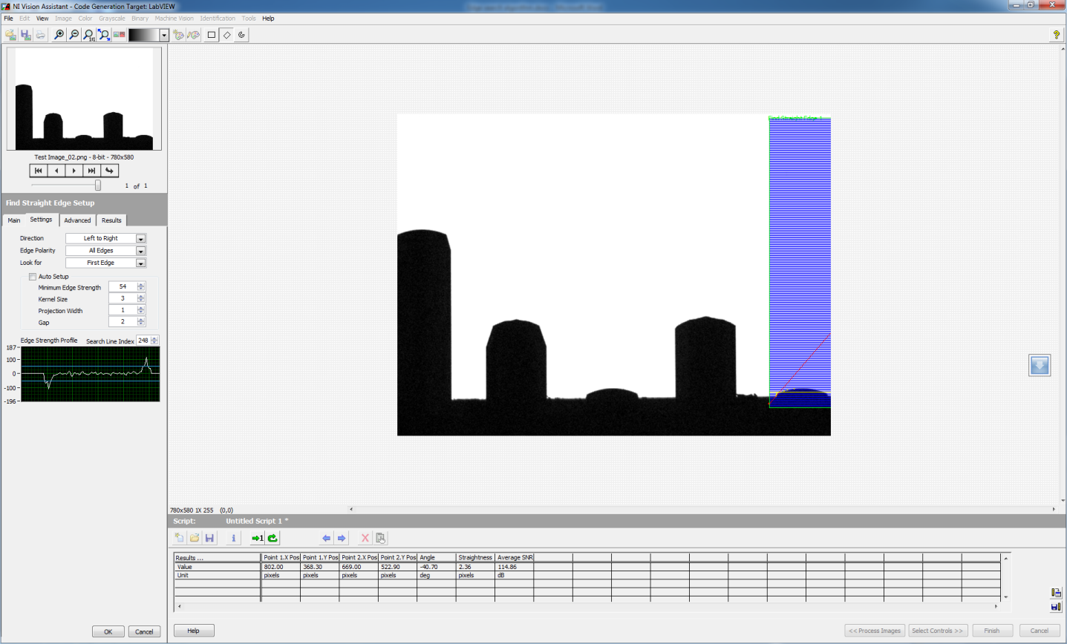

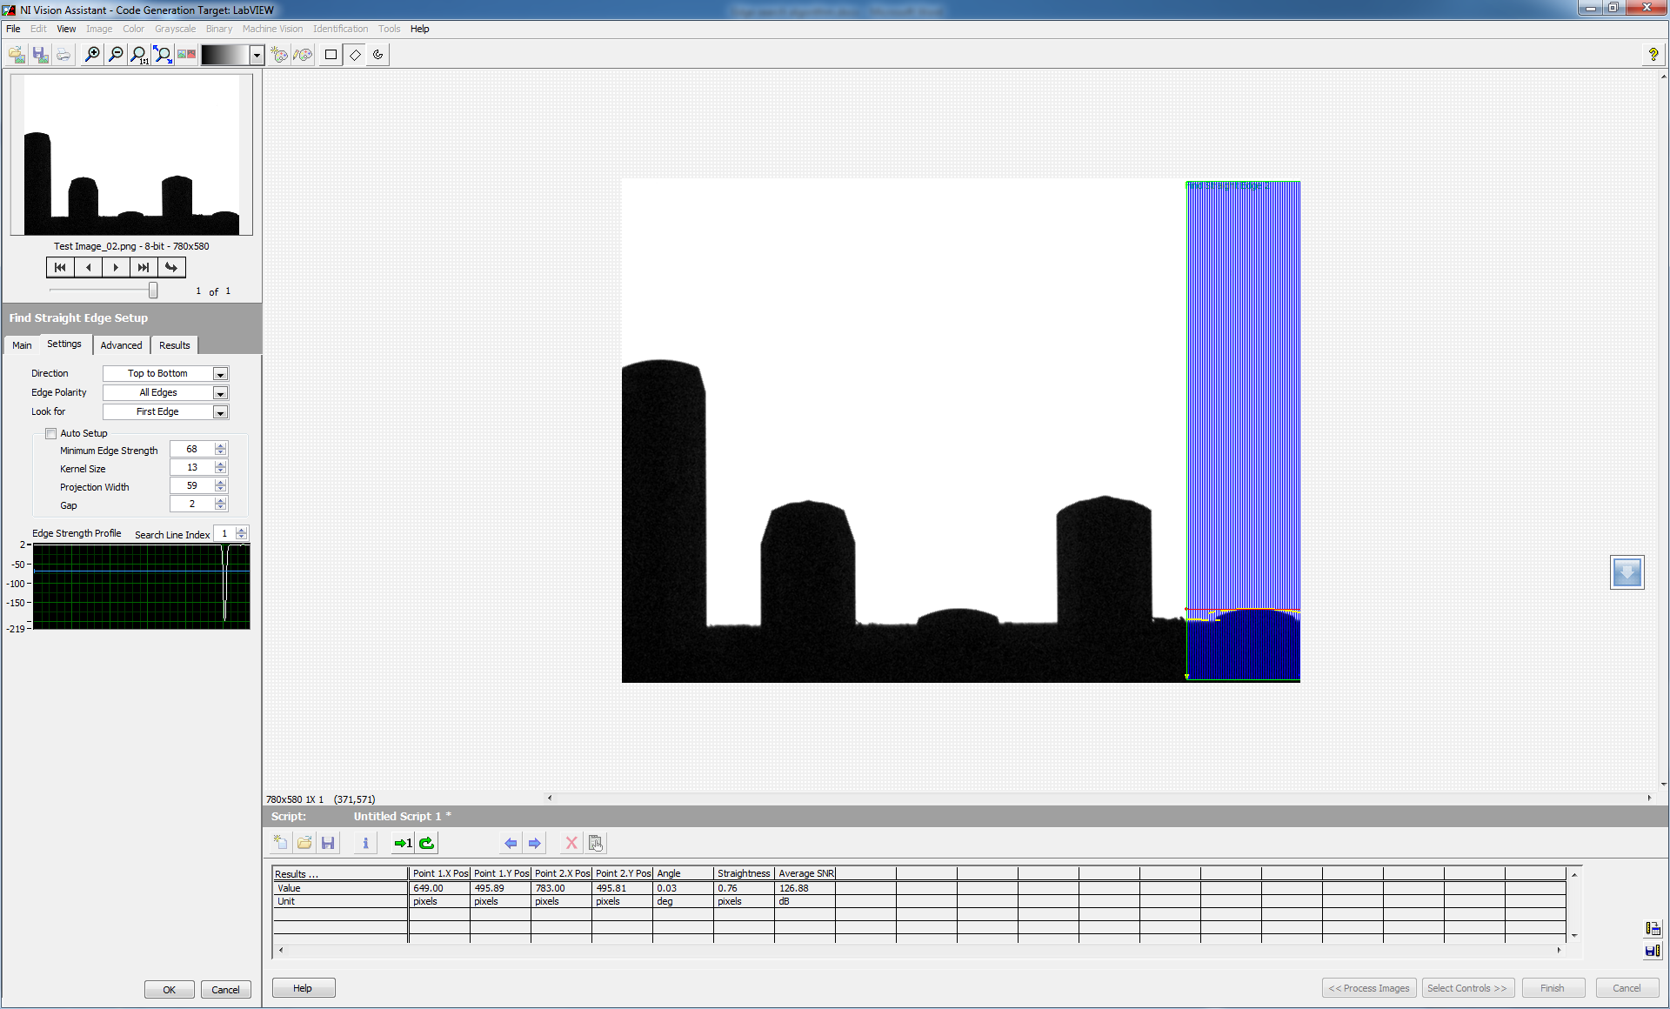

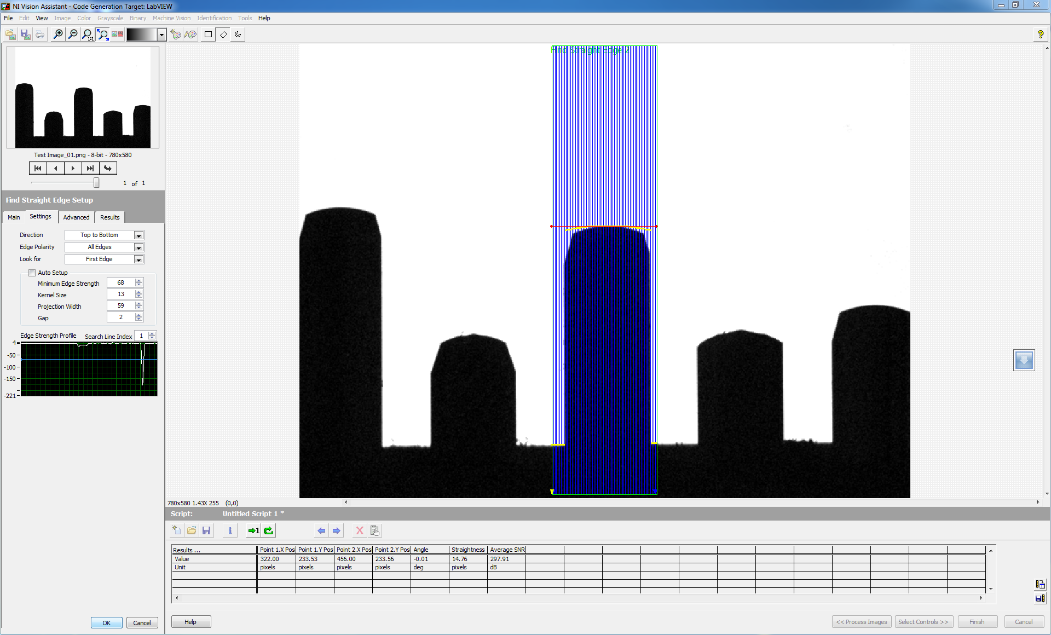

* After edge is detected, then search for the pixel intensities around this point
* Search for dark pixels (0 intensity) , count the number of columns with dark pixels and then select the columns with all these dark pixels
* Plot gradient for all these columns
* Find which column has maximum number of dark pixels
* The point or pixel where maximum gradient occurs gives the height of the point from ground reference

Overlaying line positions for edge detection

Pin 5

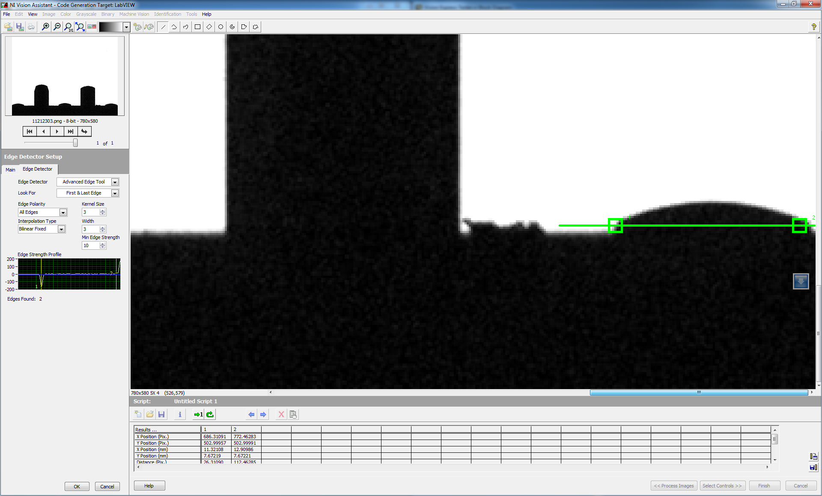

Pin 3

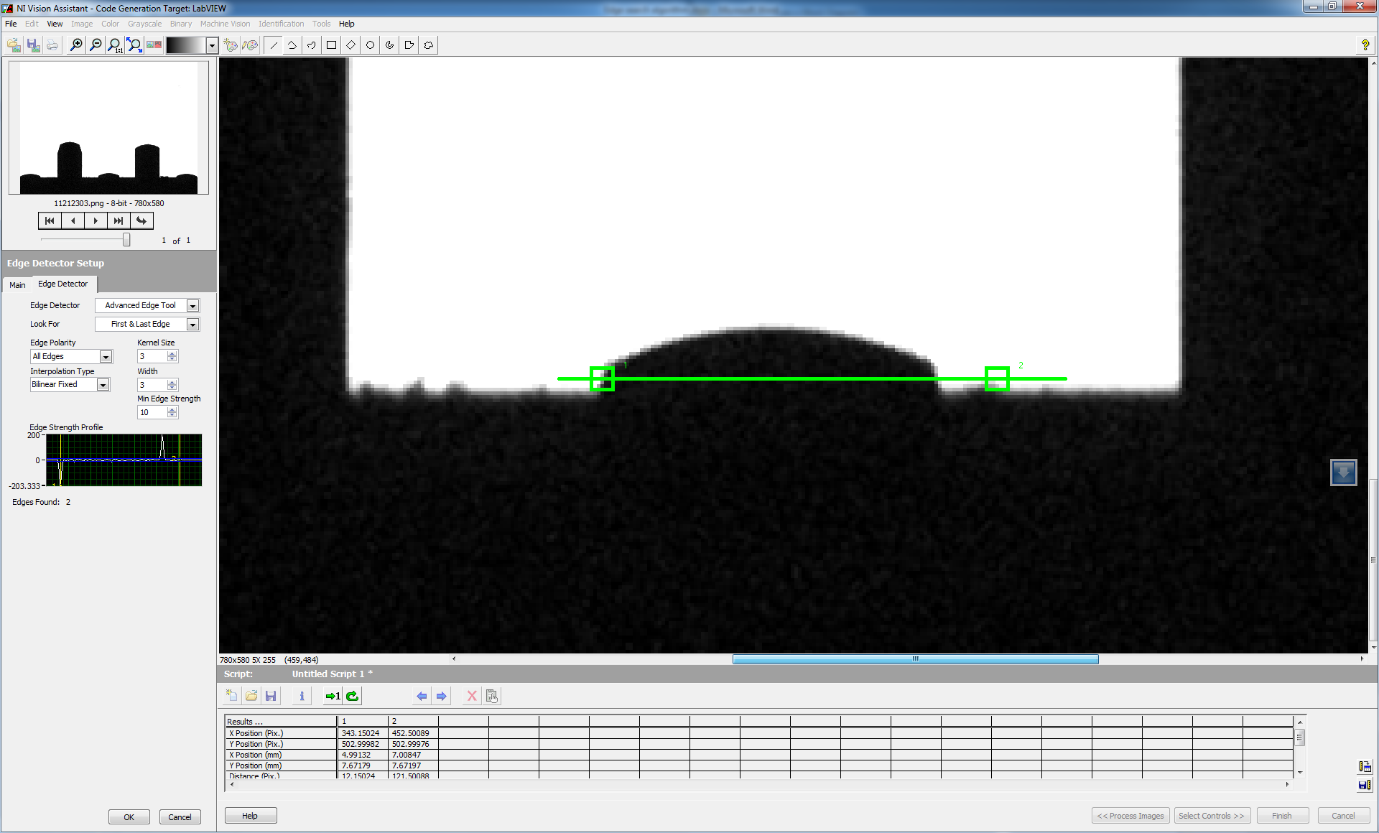

Pin 1

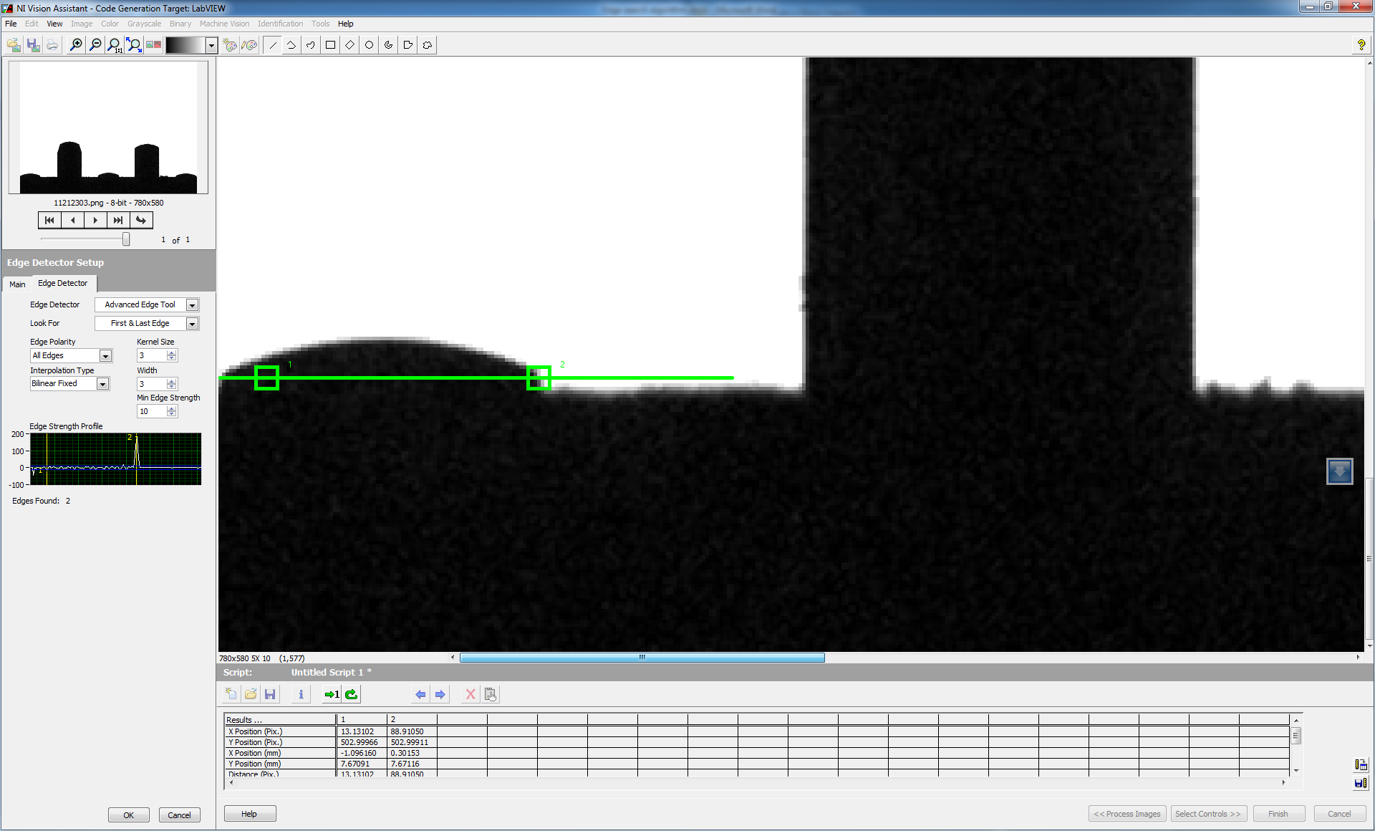

Pin 2

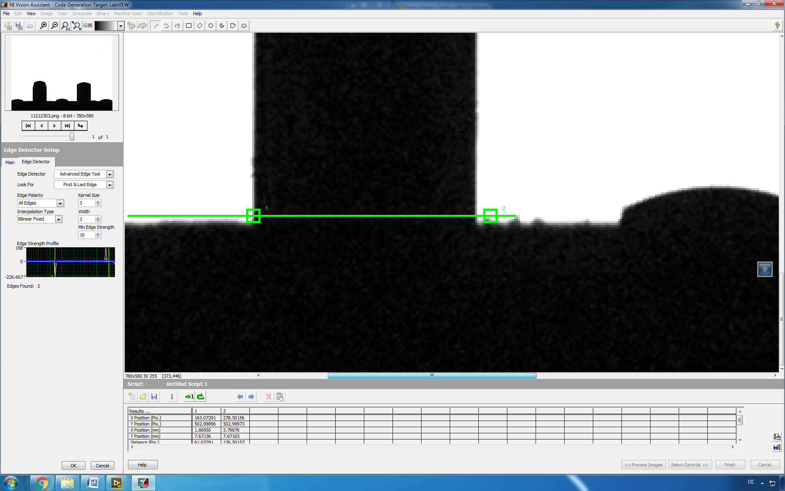

Pin 4

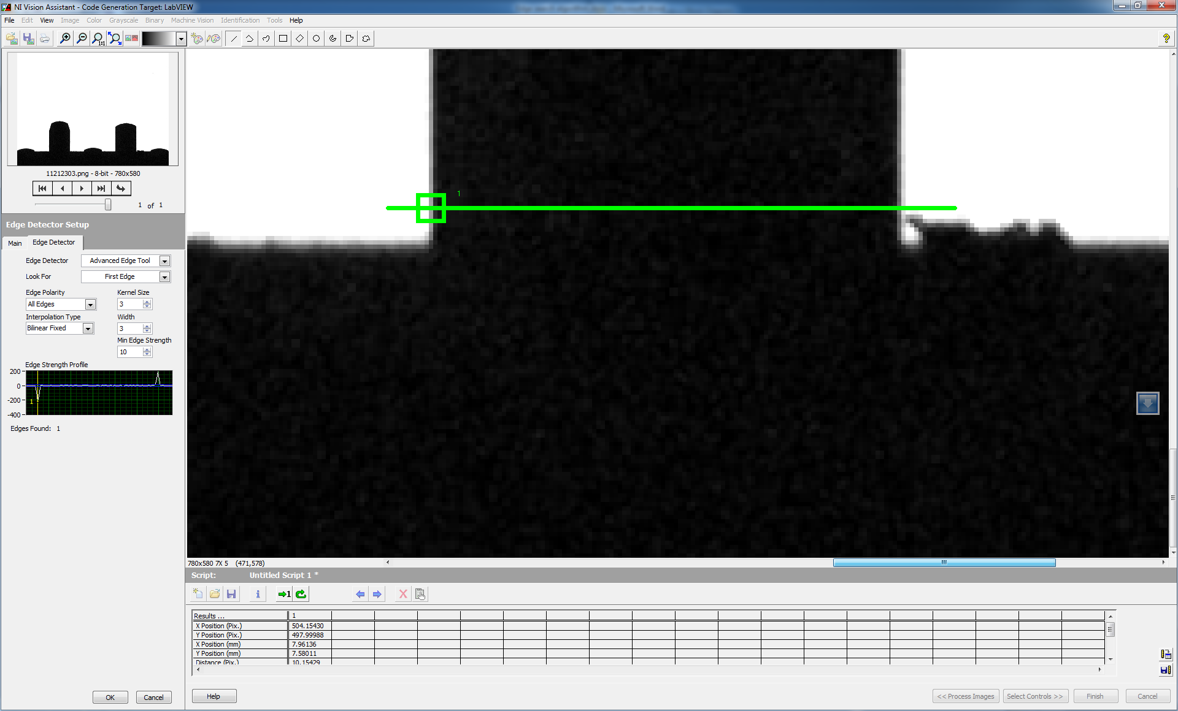

Line to ROI-Line Coordinates for each pin

|  |  |  |  |  |
| --- | --- | --- | --- | --- |
| **Pin Number** | **Start Coordinates** | | **End Coordinates** | |
|  | **X** | **Y** | **X** | **Y** |
| **1** | 0 | 503 | 120 | 503 |
| **2** | 150 | 503 | 270 | 503 |
| **3** | 330 | 503 | 452 | 503 |
| **4** | 490 | 496 | 610 | 496 |
| **5** | 660 | 503 | 780 | 503 |